Truett Bloxsom

Tsb962

Q1 results if order by percent change in profit:

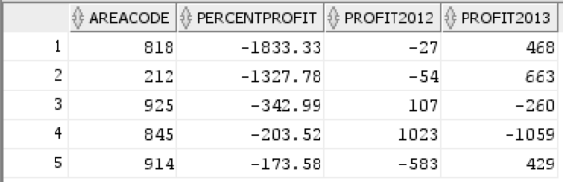

Q1 results if order by areacode:

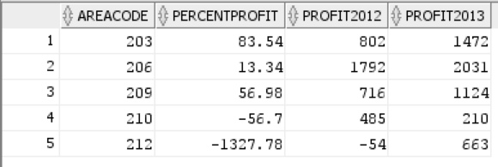

Q2 results if order by market expense:

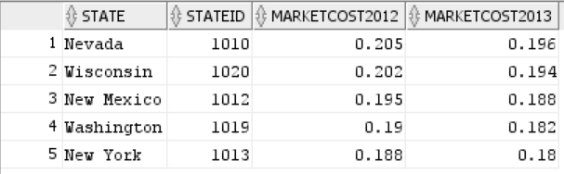

Q2 results of order by state:

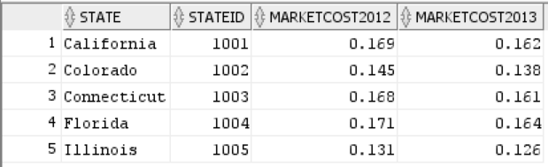

Used view that orders by marketing cost for Q3

Q3 results ordered by state and area code:

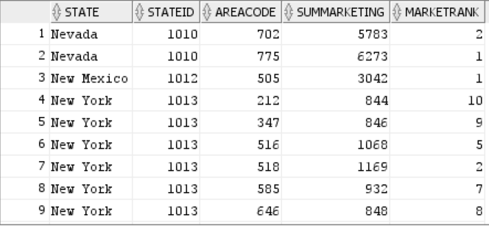

Q4 results ordered by product and market:

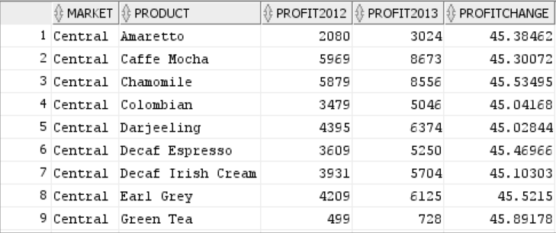

Q5 results ordered by state:

